****Packet Tracer - Examine the ARP Table****

1. Topology

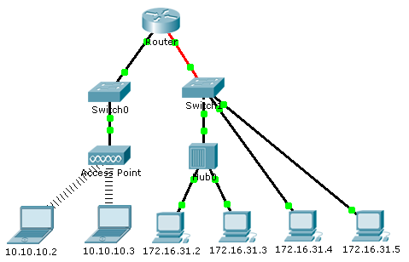

1. Addressing Table
2. Switch 0

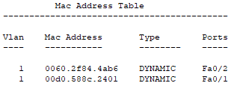

**Switch 1**

1. 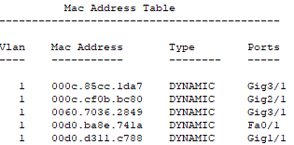
2. Objectives

Part 1: Examine an ARP Request

Part 2: Examine a Switch MAC Address Table

1. Background

This activity is optimized for viewing PDUs. The devices are already configured. You will gather PDU information in simulation mode and answer a series of questions about the data you collect.

**Read Chapter 5 regarding ARP requests (Pages 250 – 260)**

1. Examine an ARP Request
   1. Generate ARP requests by pinging 172.16.31.3 from 172.16.31.2.
      1. Click **172.16.31.2** and open the **Command Prompt**.
      2. Enter the **arp -d** command to clear the ARP table.
      3. Enter **Simulation** mode and enter the command **ping 172.16.31.3**. A PDU will be generated. The **ping** command cannot complete the ICMP packet without knowing the MAC address of the destination. So the computer sends an ARP broadcast frame to find the MAC address of the destination.
      4. Click **Capture/Forward**  once. The ARP PDU moves Hub / **Switch1** while the ICMP PDU disappears, waiting for the ARP reply. Open the PDU and record the destination MAC address. Is this address listed in the table above? _______
      5. Click **Capture/Forward**  to move the PDU to the next device. How many copies of the PDU did **Switch1** make? _______
      6. What is the IP address of the device that accepted the PDU? ______________
      7. Open the PDU and examine Layer 2. What happened to the source and destination MAC addresses? ____________________________________________________________________________________
      8. Click **Capture/Forward** until the PDU returns to **172.16.31.2**. How many copies of the PDU did the switch make during the ARP reply? _______
   2. Examine the ARP table.
      1. Note that the ICMP packet reappears. Open the PDU and examine the MAC addresses. Do the MAC addresses of the source and destination align with their IP addresses? _______
      2. Switch back to **Realtime** and the ping completes.
      3. Click **172.16.31.2** and enter the **arp –a** command. To what IP address does the MAC address entry correspond? ______________
      4. In general, when does an end device issue an ARP request?

____________________________________________________________________________________

1. Examine a Switch MAC Address Table
   1. Generate additional traffic to populate the switch MAC address table.
      1. From **172.16.31.2**, enter the **ping 172.16.31.4** command.
      2. Click **10.10.10.2** and open the **Command Prompt**.
      3. Enter the **ping 10.10.10.3** command. How many replies were sent and received? ______________
   2. Examine the MAC address table on the switches.
      1. Click **Switch1**and then the **CLI** tab. Type enable and then Enter the **show mac-address-table** command. Do the entries correspond to any of those in the **table above?** _______
      2. Click **Switch0**, then the **CLI** tab. Enter the **show mac-address-table** command. Do the entries correspond to any of those in the **table above?** _______
   3. Hint: We did not ping across the router or 10.10.10.x Network
      1. Why are two MAC addresses associated with one port?

Complete this template with your answers.

Fill in your answers **Bold** and **Red**

**Deliverables:**

Save your Answer Template using the convention of [your first initial] + [your last name] + “_Lab10”.

For example: Joe Smith will save his file template as JSmith_Lab10.doc .

Submit This **Answer Template** to Blackboard by attaching it to the appropriate assignment link.

.